Kiosk Management
Overview
Queue Waiting Rooms help advisors and front-desk staff easily manage the flow of walk-ins. Advisees check themselves into a Queue Waiting Room using a tablet or Kiosk device which is set up for a location specifically for such check-ins. Checking in creates an Advising Queue Case record for the advisee that can be tracked through the queue.

Entering the Kiosk
- Select the App Launcher.

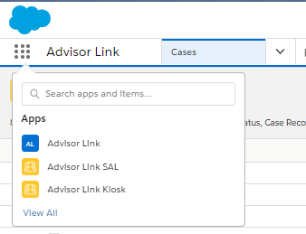

- Select Advisor Link Kiosk.

- Select a location form the Kiosk List (i.e. Woodruff Building).
- Select an available queue (i.e. ME Career).

Checking in For A Walk-In Appointment
- Choose a Walk-In Option.
  - I’m here for myself
  - I’m here for someone else
- Enter Student Name and Student ID.

- Select a Topic & Subtopic.

- An Advising Queue Case record is created, and the status is Queued

