Emails
Overview
Emailing advisees from within Advisor Link is a natural part of managing your advisee communications and appointments. Emails sent from Advisor Link are text-only. They can't include images or attachments.

Mass Emailing Students
- From the Cases tab - select the appropriate list view for the students you would like to send an email to - i.e. Recent Advisees. Select the advisees you would like to email.
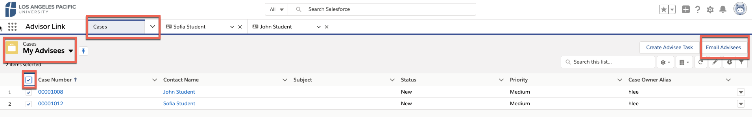

- In the far-right corner, click Send Email button.

- Enter your subject and message OR if you are using the Send Email function from the Contacts object, you can select an email template to apply that would include merge fields.
- You can then select Review to see how the email will look with the merge fields populated.

- Click Send and your email will be sent to the recipients you have chosen from the list.
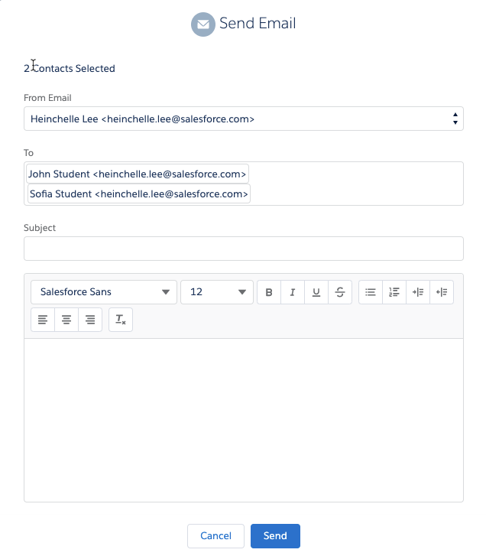
NOTE: Templates and merge fields are only supported in the Send Email function from the Contacts object, not cases.

Mass Assign Tasks to Students
- Advisee tasks can only be mass created and assigned from the Cases object.

- Choose the My Advisees view on the Case tab and select the advisees that the task should be created for.
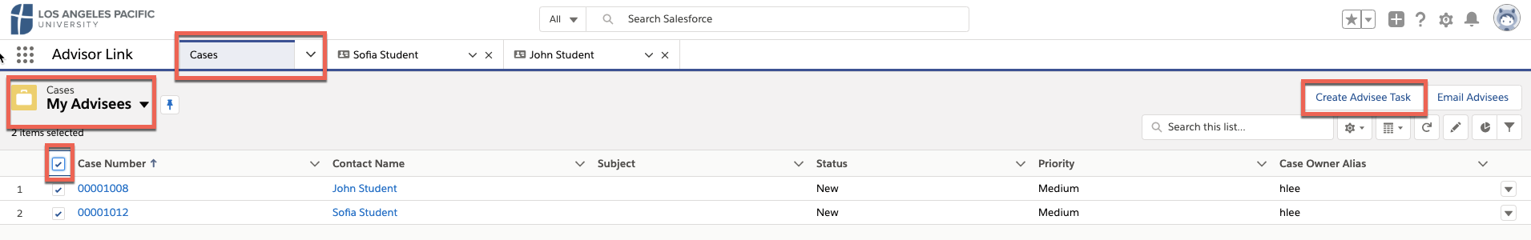

- Complete the details of the task and click Save. An email will be sent to your advisee(s) regarding the task and it will be available to them within the community to review.

- If you choose to set a reminder, the student will be alerted via a notification within the community
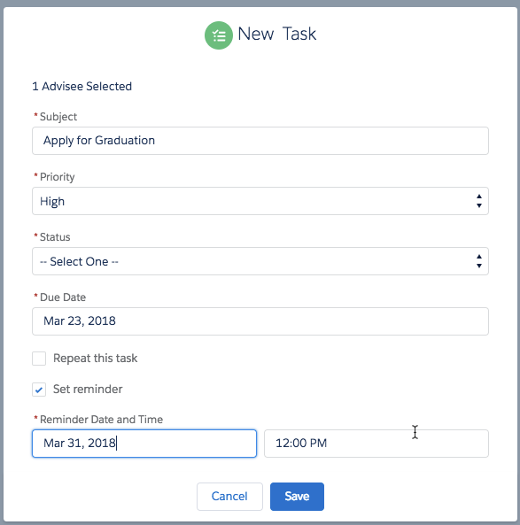

Chatter Email settings
Chatter is Salesforce’s version of instant message. This feature allows you to @ mention another contact within SAL and have an ongoing history of your communications within the organization.

- Located within the advisee case you will see Chatter to the far right.
