Riva Calendar Sync

Overview
Advisors will have calendar syncing functionality by default as part of Advisor Link. When a student books an available block of time in Advisor Link, this is added to the Advisor’s appointment manager and then synced by Riva to Outlook. Outlook is the only Institute supported calendar for Riva.
Do not change the category colors! The colors in their current configuration need to stay the way they are. If the color is changed, Riva will stop syncing internal events.
Advisors can create Outlook events through the normal process. If this is a recurring series make sure to disable “All day event”, before putting in the recurring series details.

Considerations

Availability is shown in Office 365 as “Advising Time” as set in Advisor Link’s Appointment Manager
Walk-in Time is shown in Office 365 as “In-Person” as set in Advisor Link’s Appointment Manager
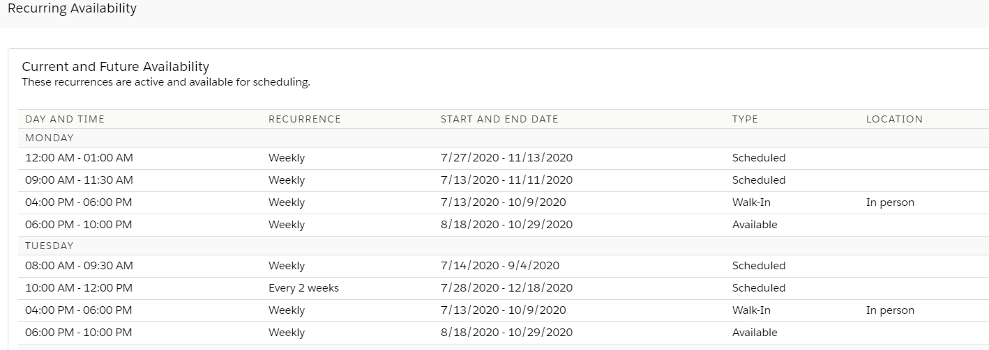

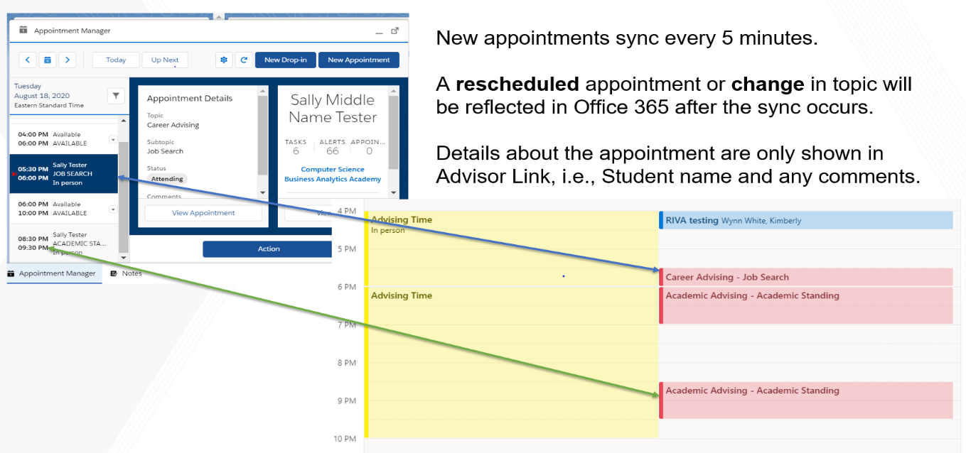

Cancelled appointment time will immediately show as “available” in Advisor Link for another advisee to book.
Cancelled appointments are sync’d every 30 minutes in Office 365. A double booking in Office365 is an indication of a cancelled appointment. Refer to your Advisor Link Appointment Manager to view upcoming appointments.
If set in the Appointment Manager, advisors will receive an email notification of the cancellation.

Removing Advising Availability Due to an Internal Conflict
